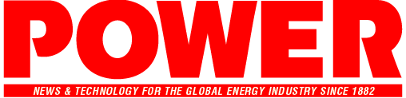
POWER magazine’s 2025 Community Impact Award
OFFICIAL ENTRY FORM
(All nominations are due no later than September 5, 2025.)
Instructions
Description: This award honors an organization or company making a meaningful difference through community-focused energy initiatives. Whether advancing energy equity, investing in workforce development, or supporting local sustainability efforts, the recipient demonstrates a deep commitment to creating lasting, positive change beyond their business objectives.
Eligibility: Nominee must be a company or organization (not an individual).
E-mail this completed nomination form and any supporting materials to: awards@powermag.com. Your nomination package will be acknowledged by a return e-mail within a day or two. If you do not receive confirmation within three days, feel free to send a follow-up email.
Please fill out this form electronically to ensure that we can read your submission and process it appropriately.
1a. Name of company/organization being nominated:
1b. Location of headquarters (City, State, Country):
1c. Location of community engagement effort (if different):

2a. Contact person for submission:
2b. Job title:
2c. Company/organization:
2d. Email address:
2e. Telephone:

3. Include an overview of community initiatives and how they alignment with the group’s mission (max 750 words). Please provide measurable outcomes or success metrics, if possible
Optional: Supporting materials may include testimonials, news coverage, photos, and other reports. You may also enter any additional documentation that helps demonstrate why the company/organization should be considered for the award.
Please return this form, description, and any supporting materials via e-mail to awards@powermag.com by September 5, 2025.
Use Community Impact Award nomination as your subject line.

